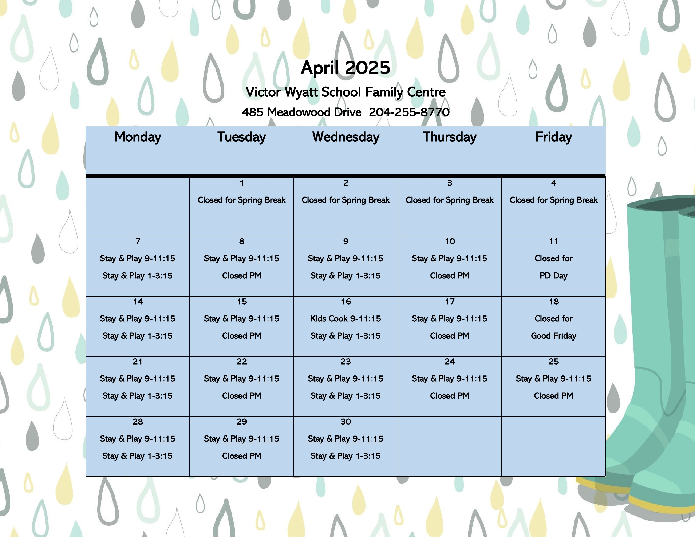

|  |
| --- |
| **March**  **Stay & Play Drop-In Program**  **Morning Drop-in;**  Monday—Friday  9:00-11:15 am  **Afternoon Drop-in;**  Monday & Wednesday  1:00-3:15 pm  **Bring your child (birth-5 years old) for free play, art activities, songs, stories, movement activities and much more. A**  **healthy snack is provided for your child.**  **Meet other parents and caregivers. Pick up helpful ideas about caring for your children. Take advantage of our Book and Toy Lending Library.**  **All programming is FREE!!!!**  **\*\*Shoes must be worn in the centre at all times for safety reasons. Feel free to leave a pair here for you and your child.** |

|  |
| --- |
| What’s New  **Kids Cooking** will be on Wednesday, April 16th. Children and caregivers will be making a fun and nutritious snack together.  The centre will be closed for on Friday, April 11th for a day of staff learning and on Friday, April 18th for Good Friday.  As always, remember to check out our lending library. Your child may borrow books, games, busy bags and puzzles from the family centre.  As the weather warms up, we will be heading outdoors for some play time so please always be dressed for the weather.  ***Please remember that if you or your child are feeling unwell, stay home to rest and recover. We look forward to welcoming you back when you are feeling better!***  If you have any questions or comments, please feel free to contact Leona @ leona.howika@lrsd.net or 204-255-7880.    *For more information about LRSD Family Centres: https://www.lrsd.net/page/1509/family-centres* |

Our **Little Sparks Ready for School Program** will be offered April 8th-May 22nd, two half days per week on Tuesday and Thursday afternoons.

**This program is exclusively for children entering Kindergarten at Victor Wyatt School in the fall of 2025.** *Please contact Leona at 204-255-7880 or leona.howika @lrsd.net for to register your child.*