Propel Final Presentations – June 18,19
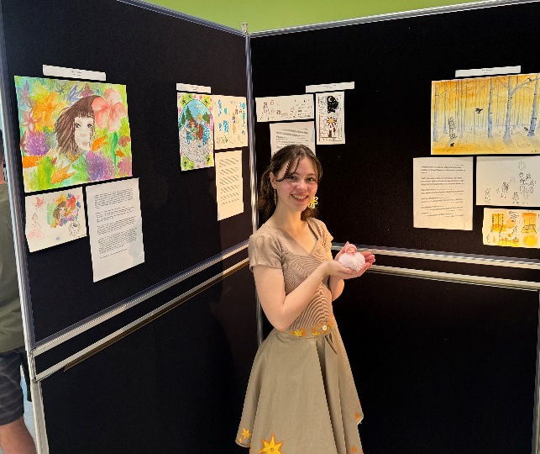
Congratulations to our 12 CJS students, who participated in the school’s inaugural Propel program, for their excellent final presentations that were held in the cafeteria over 2 days last week. Propel is an interdisciplinary, project-based learning program where students earn 3-4 credits while pursuing individualized areas of interest. It has existed as a program within the division for several years but is now offered “en français” for students attending CJS.
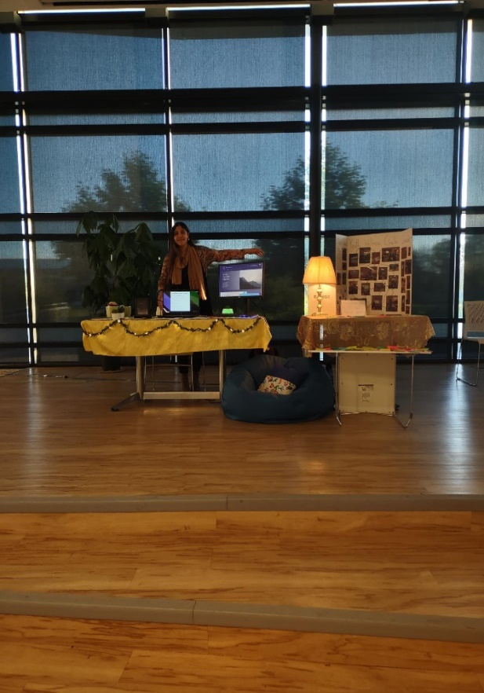
The final presentations were the culmination of four and half months of hard work, where students shared what they had learned and created this semester. From novel writing to video game development, movie production, and everything in between, the creativity and execution of these presentations by our students were exemplary.
Propel will be offered again during the 2024-2025 school year in the second semester. If you have any questions about the program, please contact Monsieur Albrecht or your student services advisor at the school, and they will be happy to answer your questions.

