SPC ANNUAL GENERAL MEETING

- Executive:
  - We currently are looking to fill vacancies on the executive:
- Co-Chair
- Co-Chair
- Treasurer
- Secretary
- Constitution
  - Review
  - Proposed amendments to the constitution
- Budget proposal for 2024-25
- Administrative Report
- New business
- Next meeting dates

ADMIN REPORT-PAC September 17, 2024

LRSD NEWS/PRIORITIES
DIVISIONAL CELL PHONE POLICY FEEDBACK
Although we have already established cell phone use guidelines at EGM, the division is in the process of creating a Divisional policy that reflects the new ministerial guidelines on cellphone use. As we draft this policy for the Louis Riel School Division Board of Trustees to adopt before November 1, 2024, we will regularly check in with students, staff, and families to gather feedback and make any necessary adjustments. Please use this MS Form to share your thoughts on the draft policy.

Ministerial Guidelines | LRSD Policy | Feedback Form
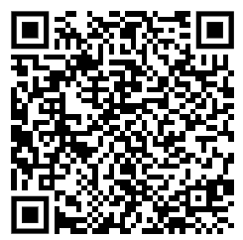 | 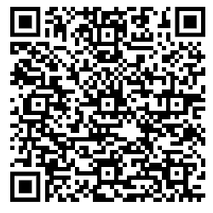 | 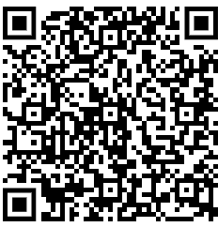

SCHOOL START UP THOUGHT EXCHANGE
As we start the new school year, the Louis Riel School Division wants to better understand what’s top of mind for you. Your insights will help our Senior Leadership Team support you more effectively. Please share your thoughts in the Thought Exchange.

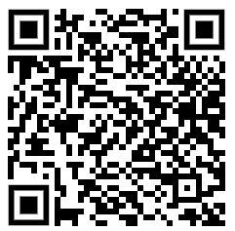

EGM UPDATES/PRIORITIES

WEEK OF TRUTH AND RECONCILIATION
To recognize National Day of Truth and Reconciliation, we will be having an assembly on September 27th where students will share their understanding about truth and reconciliation. We have a committee of teachers currently planning events and lessons for the week and we expect it to be similar to what was planned last year.
- Witness blanket exploration (virtual exhibit)
- Lesson plans around truth and reconciliation
- Assembly with guest speakers and shared learning from the Witness Blanket exploration.
- Friday Sept 27 PM: Orange Shirt Day

UNIVERSAL NUTRITION PROGRAM
The province has provided all school divisions with fuds to provide food to students. Our school has been given funds to provide daily grab and g snacks. We have a variety of options available (fresh fruit, crackers, granola bars, apple sauce…). Our goal is to provide all students with an opportunity to access this food if they are hungry throughout the day. We have been speaking to the students about respectful food consumption and food waste with an expectation that students do not waste food from home by choosing school snacks instead.
EXTRACURRICULAR SPORTS
Cross country and volleyball are underway. We have found enough coaches to coach all teams. The jersey store is open until Sept. 30. Students can purchase a jersey for remaining sports (they will not arrive in time for cross country or volleyball season) or they can borrow a jersey from the physical education department.
TECHNOLOGY
Staff at ÉGM use instructional technology to teach the skills, knowledge and behaviors students will need as responsible citizens in the global community. Students learn collaboration, communication, creativity, and critical thinking in a variety of ways throughout the school day. Students in grade 6, 7 and 8 will have access to a shared device throughout the school day. The use of personal devices by students is optional, and only those who want to bring their devices to school should do so. Students will not be allowed to use laptops during the lunch hour (personal or school laptops) unless under teacher direction/supervision.
CELL PHONES
Please read the revised cell phone policy and provide your feedback:
We prefer that students leave their cell phones, wireless headhpones and smart watches at home (“devices”), but students who need to bring themto school (ex. communication after school or after practical arts), must keep their phones turned off off and store their devices in their lockers during the school day (including lunch and recess). These devices are not allowed between 8:20 a.m. and 3:03 p.m. Students attending practical arts will not be able to access the devices during practical arts class times and will be expected to put them in their lockers as soon as they return to the school. If a student is having trouble complying with the policy, a staff member will direct the student to our office, and their device will remain in the office for the day. If a student continues to use their cell phone in class, hallways, and bathrooms, we will have a parent pick up the phone at the end of the day or as soon as possible.
NATURAL HELPERS
Selected Grade 7/8 student will participate in our Natural Helpers Training Dec 1, 2, 3 at the Monterey Board Office. This is a training retreat that encourages empathy and peer support among youth. Students are nominated by their peers and identified as natural helpers. The training serves to enhance the natural skills identified in these young people by their peers.
GRADE LEVEL OUTINGS
Grade 6 students will participate in a day in June. The exact date, location and cost is yet to be determined. Another day activity may be planned at another location as well.
Grade 7 students will participate in an overnight ski trip February 6, 7. Cost for this is just approximately 300$ per student.
Grade 8 students will participate in a 3 day (2 night) at Camp Stevens in Lake of the Woods. Cost for this is approximately 300$ per student. Dates still to be determined (May or June).
School level fundraising will be held for these events and financing will be provided for all students that require support.

