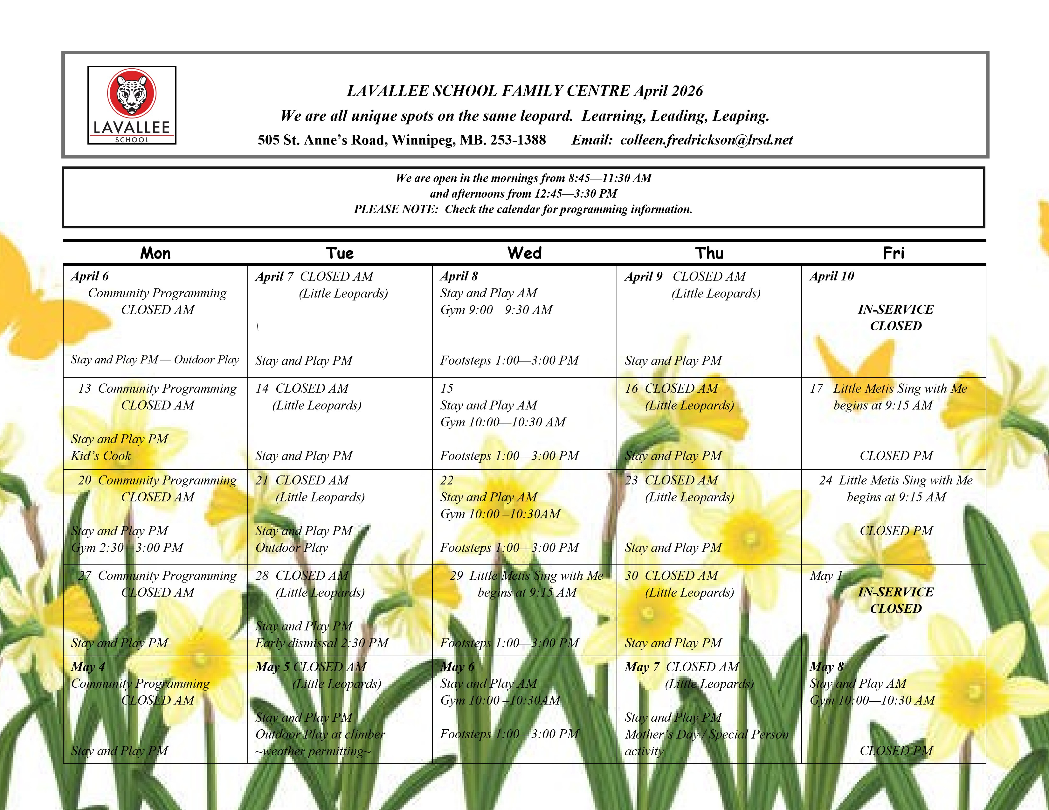

  Join us for an exciting parent-child program with Metis flair
  
  Activities include:
  •Songs and rhymes
  •Story time
  •Children’s play time
  •Parent discussions, cultural activities, and crafts
  •Metis music and jigging
  •A delicious snack
  Little Metis Sing with Me begins on Friday, March 13 at 9:15 AM and continues on the following mornings: ●Wednesday, March 18
  ●Friday, March 27
  ●Friday, April 17
  ●Friday, April 24
  -Wednesday, April 29 from 9:15 AM – 11:30 AM
  Please contact the Family Centre to let us know that you will be there!
  Little Metis Sing with Me at Lavallee School Family Centre is supported by the
  St. Vital Parent Child Coalition - Empowering families in raising healthy and thriving children through impactful local programs & resources.
  ~Footsteps~
  Wednesday afternoons 1:00—3:00 PM.
  Come join us for an afternoon of connection and crafting.
  The Footsteps program brings adult community members together to craft,
  bead, sew, and work on their own projects in a supportive environment.
  If you have any questions about the program, please contact:
  tammy.bruce@lrsd.net
  Limited childminding space is available in partnership with Lavallee School Family Centre.
 | 

