Thursday, February 19th - SPC Meeting Minutes
7pm EGM Library

Present: Alinea Piche (Treasurer), Lisa Hettrick (Chair), Rhonda Dube (Secretary), Britta Krahn, Dawn James, Tyler Milloy
Regrets: Lisa Holmes, Shannon Baxter (Vice Principal), Kristin Morand, Mary Thomson, Amanda Downie, Sarah Mitchell, Lindsey Henderson, Nicole Hacault, Karin Holmes

- Guest Teacher- no guest teacher this week.

- Approval of January Minutes- no changes noted.

- Approval of February Agenda- item addition: Constitution (Alinea).

Alinea noted some areas of the constitution from October 2024 that require updating: current document is not date & clarification of what ‘active member’. Alinea also noted a statement re: ‘When consensus cannot be reached ‘Roberts rules of Order’ will be used, which is not clear. Alinea to work on wording & clarification and bring to next meeting. The constitution should also be voted on to be adopted, which we will do with the revised constitution.

- Budget Update (Alinea)

Fundraising income-
-Healthy Hunger- YTD profit- $1,365.85 ($1,590.68 of total profits minus $225.83 spent
on extra lunches)
-Spenst Pizza Fundraiser- $1292.98 total profit

Gaga Ball Pit- SPC has almost $4,000 available and the school has another $5,000. We are
approaching $10,000 worth of funds and the last quoted number for gaga ball pit and basketball net was $15,562.56. We should revisit our exact dollar goals to begin more concrete planning for the equipment (send from Alinea’s email).

It seems the conversation had stalled for some time because of a miscommunication between funds in account, as for some time there was not sufficient funds based on the quotes received. This was not documented in previous minutes.

Discussion of basketball net. Tyler noted that at last discussion the cost was pricey. The plan was to install the net near where the kids wait for the bus (by the wall). Tyler had received varying quotes from various companies. In discussion of the gaga ball pit, it has been some time since a quote was revisited. Materials debated: plastic vs wood. Kids may take lighters to plastic & questionable durability. Discussion about whether specific vendor needs to be used that is approved by school board. If not, then could someone make a wooden gaga ball pit? Previous quotes had included the recycled rubber base which would increase the price. $3000 for basketball net, $9000 Gaga ball pit & mat $4000, installation for both was $7000. Discussion about if the mat (rubber base required) as it could go on the concrete (which is school property). Would it be moveable for the winter? Tyler to look into getting another new quote & options.

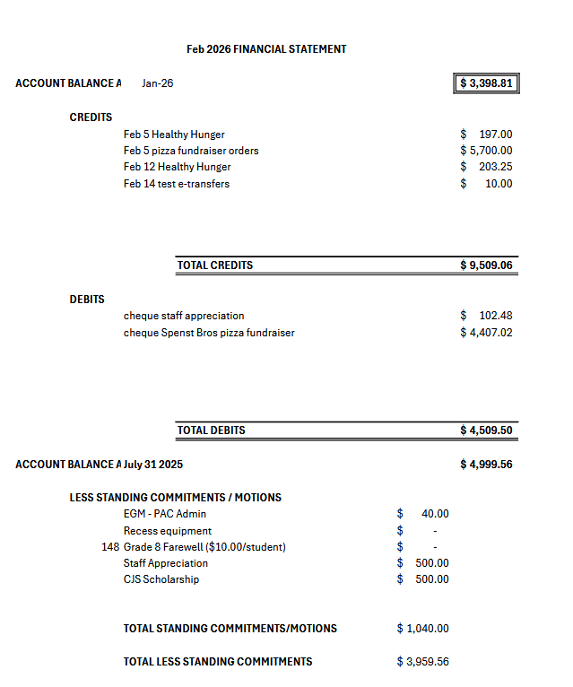
5. Succession Planning (Alinea)- Discussion on how to ensure roles are captured and passed on for chair & treasurer. It is likely not required for secretary, except for lacking a place to house documents. Rhonda to send minutes to Lynn for posting on the EGM website, which will help with ensuring they are available. Discussion had about capturing areas of the 2 roles (treasurer & chair) in a written summary, but it is an extra task to require of volunteers in the roles. Alinea suggested dedicating time during the meeting to having a conversation & documenting various aspects of the role. Ie. Alinea has set up an email account for fundraising where all emailed documents will be housed for future reference. Discussion had about Lisa Hettricks role (as she will be leaving @ the end of this year). This would be valuable in preparing in advance for upcoming events to be planned or fundraising (ie. getting our name in for ‘Peak of the Market’ early on or planning of the year end event). Succession planning will be added to agendas going forward as ideally this discussion should occur before May to ensure set up for September.

4. Administration Report (Tyler)
Grade 7/8 dance was held last week & not as well attended (approx.50 students) as Fall dance (approx. 100 students).
Color competitions in January which was fun. This will occur again in June.
Grade 6 dance- January- was well attended
Re-review tour to classrooms by Tyler/Shannon of visiting classes of expectations. Gr. 6 tour/tone is more about routines & Gr. 8 is more about finishing off the year strong.
Gr 8 went to CJS for visit & now submitting course selections
February- diversity was the theme. Festivale du Voyageur days had dancing & performance.
Tomorrow afternoon (Feb 20)- outside festival stations (bonfire, hot chocolate, Bannock, furs).
Next week- Black history month celebrations/activities & ski trip gr. 7
Last week- dress as your culture day.
Term 2 report cards & student expo night 26th.
March- mental health theme
March 18 parent info night for camp stevens @ 5pm. Will plan to have SPC meeting after the camp meeting. Ie. 6pm.

Additional funding approved from division. Not a lot but does contribute to staffing.
Enrollment is down by 20 kids next year & up by 40 following year.
3 mat leaves for next year. Not expecting many other staff moves but pending requests.

Tyler shared with the group that they were thinking about polling families about trips. Costs increasing for Ski trip & camp. Approx. 12 students not going on the ski trip for various reasons. Funding provided for some students. In the past freezie sales & bake sales were done to offset individual costs. Currently pizza days make approx. $400.

5. Fundraising Update

  - Healthy Hunger (reported in budget review)
  - SPC planned initiatives; spenst pizza, krispy kreme

From Lisa Holmes: Spenst Pizza Update: We sold 564 pizzas and 12 baking kits. Our profit was $1,293.
As an alternative in the future suggested: Archie’s Pizza as there are gluten free options.

Summarized from Lisa Holmes- some dates updated: Krispy Kreme Fundraiser: We would like to roll out this fundraiser on Thursday, February 26th * (2 weeks) and the final day for orders would be Thursday, March 12th (* updated date different from email as per committee members) as we need to adjust our order numbers at a minimum, 1 week prior. We want to be sure that all online orders have been paid for. I'm in the process of developing an online form that will automatically go into a spreadsheet for data collection. Alinea has confirmed that etransfers can be accepted by the SPC bank account.
We would also have some order forms in the office for student pick up and email for those that wish to print them at home. Cash and Cheque would also be accepted.
I will test out the online order form and spreadsheet before Thursday's meeting and share it with the group to go over in case I'm missing any important details.

Here is the Krispy Kreme form to go over at the meeting (see link). We would publish this link in the weekly announcements that are sent out by Tyler. Extra copies will be printed for the office for families that do not want to pay by etransfer.

https://docs.google.com/forms/d/e/1FAIpQLSd6GGhzHHtwm106-ZWULhG80Sjmo0tbaMO2dk0uJYHuiRDXtA/viewform?usp=header

Fundraiser Details:
-Numbers need to be submitted on Monday, March 16th
-A cheque is due 2 days prior to pick up.
-We are limited to selling 100 dozen at most and 25 dozen at a minimum. (Do I need to specify this on the form?) Committee felt no as if we get close to 100 dozen can wind up orders.
-Selling price of $16 and the cost to us is $8/dozen.

Costco currently is selling the Krispy Kreme donuts until March 1st at a significantly reduced price.

Printed order forms available in office. Posters not needed for within the school, but just attached to the email.

  - School planned initiatives; no discussion
Lacoste- Lynn will organize for Mothers Day, pizza lunches- pending.

6. Updates of Initiatives: Ice rink- no update as it’s up & running, Cricket- not pursued further @ present. Tyler thought it might be too close to soccer field or baseball diamond which is Dakota Community Club property, so would need their approval prior to further planning.
Community event- not discussed @ present.

7. Communications (ie. Instagram)- Dawn James- will post Krispy Kreme advertising. Lisa Hettrick suggested for Dawn to send a shout out/thanks to the community about the success of the Spenst pizza fundraiser. Discussion about Facebook. If used in addition to Instagram, it would need some monitoring. Communication with other schools and being aware of their event planning has been problematic. CJS is planning to reach out to coordinate days of activities.

8. New Business
Last PD was an update on reconciliation. Planning for future Land based learning- ie, at Henteleff park and partnership activities with the committee. Tree planting in summer, guided walks, laying wood chips. Lisa H does plant walks. St. Vital park. Connecting with residents & build community

Upcoming/Next Meetings

March 18 (early time- 6pm?)
April 22 (April 15 falls on admin night)
May 20
June TBD

Teacher Appreciation Meeting- Tyler was consulted for staff preference: sandwiches, wraps or pizza. Tyler to check with staff.
Email from Alinea:

Hello all,

I know not everyone will be able to see this before our meeting tomorrow, but I have made a sign up genius for staff appreciation week (March 16-19, with the 20th being a PD day). Let me know if it's missing anything: https://www.signupgenius.com/go/30E0849AFA92BA1F58-62386580-egmstaff

And I have looked into a few different options for lunch on the Thursday of that week that might fit our budget (see attached).

Assuming 35 staff. Budget is $400

Subway- platter of 15 four-inch sandwiches, serves 5-9- $57.59. Featuring the Cold Cut Combo, Black Forest Ham, Turkey Breast, Tuna and Italian B.M.T.® All sandwiches come standard with processed cheddar, lettuce & tomato
Toppings platter ( lettuce, spinach, tomatoes, cucumbers, green pepper strips, olives,
pickles, and onions) to customize sandwiches. $18.99
Five sandwich platters plus two toppings platters= $325.93 plus tax (assuming a platter will
serve 7= 35 staff)
We could order individual sandwiches for gluten free or vegan

Sobeys- sub or wrap platter both $50 for a large platter (serves 10)
Salads- $42 each (serves 10) (gardener’s harvest salad appears to be vegan)
Four sandwich/wrap platters and three salads= $326 plus tax

Dominos pizza- x-large pizza serves 5-6, $30.80 (including tax) gluten free crust option available.
There may be a catering price with a minimum order, we would have to call to find out
8 x-large pizzas= 246.40

