January 21st - SPC Meeting Agenda
7pm EGM Library
Present: Karin Holmes, Shannon Baxter, Tyler Milloy, Lindsey Henderson, Lisa Holmes, Alinea Piche, Nicole Hacault, Britta Krahn, Rhonda Dube
Absent: Lisa Hettrick, Kristin Morand, Dawn James, Mary Thomson, Amanda Downie, Sarah Mitchell
- Guest Teacher: Madame Shannon Magnifico popped in while stepping away from the egrade 6 dance. Madame Shannon teaches grade 6 and is new to the school. She teaches 3 diff groups- arts, science, math & ELA. Some upcoming trips for the grade 6’s, one being: Project 11 @ the moose game- in health students are learning about being good friend/support.

- Approval of November Minutes- approved with no changes.

- Budget Update- provided by Alinea- see balance below
Direct deposit for healthy hunger is now set up & streamlining deposits.
Approx. $40-$50 ordered for extra lunches which is appropriate for need.
Skating rink – no budget allocation due to Marcus Chambers donation of $2000.

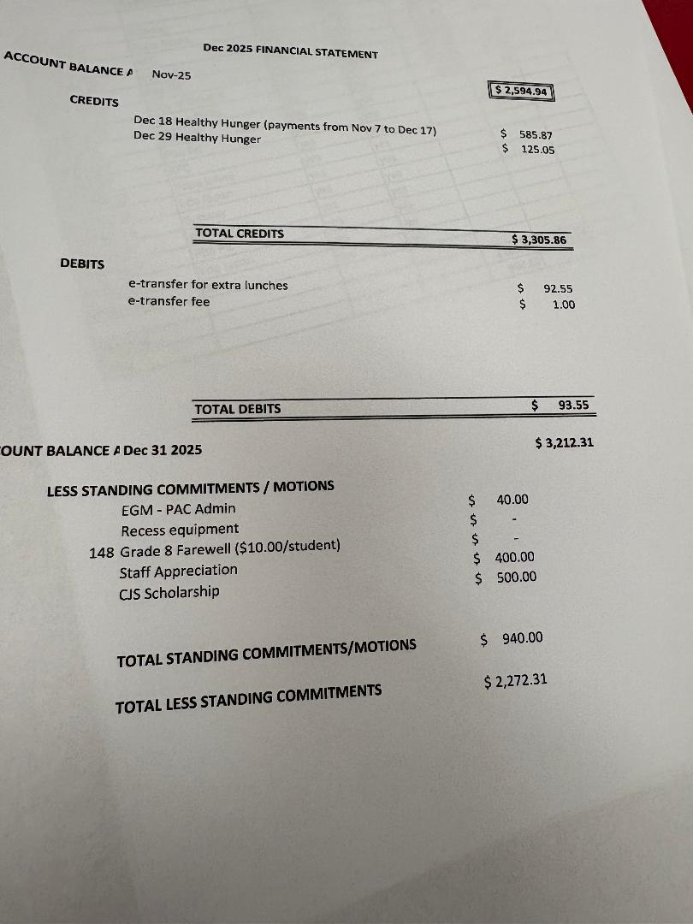

- Administration Report

Switched up format of conferences to be 1 longer evening instead of 2 shorter evenings. Karin gave feedback that it worked well for their family.
Volleyball wrapped up. Basketball now in progress.
Guitar concert in Dec- went well.
2 full days of Natural helpers- moved into December.
Student leadership- Dec theme- generosity. 1100 items collected for donations. 8 Hampers created & delivered to local families.
Skating rink- Marcus Chambers contributed $2000 for expenses. $1600 balance so far. Bought some skates & helmets. Approx 12-20 kids out @ recess. JAG has dedicated 1 group each morning. Tyler floods it daily.
Peer tutoring. Mostly gr 8 helping gr 6. (some gr. 7 helping). Well attended.
Jan theme- new month- new me. Noted on the outdoor sign. Last Friday- outdoor activities moved indoors due to weather. Activities (ie.Blookit- like Kahoot) that align with the “Healthy” theme. Thursday will hold the color competitions (formerly known as grade wars).
Feb theme- diversity. Will be a busy month with Festivale- outdoor activities, pancake breakfast. Black history month- assembly & movie. Ramadan & Indigenous perspectives to be incorporated. Students have suggested a culture day- dress up in your culture.
Gr. 7 ski trip- Tyler will be attending. Shannon will be attending Camp Stephens later in the year.
Draft review budget tonight.
Controlled access to schools- no investigation required related to the last incident as it seemed to be a community member using the washroom, but police were involved & all investigations done. Discussion had with students re: opening the door for people or alerting staff to unknown people in the hall.
Plan for camera with buzzer @ the front door. Currently an intermittently working doorbell is installed. Office staff are able to see the front door.
Temp limit- all schools using the forks environment Canada site. -27 to -29 is okay for 15 min outside. -30 = no time outside. Discussion had about kids dressing warmly ie. wearing ‘under layer’.
Discussion about Minecraft offerings, not happening. Overlap in the D & D club? Tyler will look into.
M. Dan offers indoor game time for kids who want to stay in. Usually a theme ie. soccer.
Questions from members:
Discussion had about Art only as an option in 7 & 8, but not required. Some kids may find it hard to choose between the options. Argument could be made that all options have some art component.

Absence message app- not able to alter feedback. Called school to update. Not all aspects of app may not be functional as it’s new.

- Fundraising Update

  - Healthy Hunger- see notes above under budget.
  - SPC planned initiatives;
Spenst pizza- Forms in parents hands was decided to be best for this fundraiser with plan to go paperless in the future. ESG does forms & e-transfer. E- copy in next 2 messages home from Tyler. 1 form/ family to be sent home. Thursday, Feb 5th is deadline- Lisa H & Britta will count money on the 5th. Alinea will deposit it & be available on that day as well. Flyers to be posted in the school.
Students to take home- bags for kids will be provided if they don’t bring any. P/u 3-5pm. Option for parents to pick up. Check box on the form for parents to indicate they will pick up.
Krispy Kreme: Will be available on the Thursday of parent conferences (Mar 26) . CJS had sold for $16. Cost is $9. Decided that we will charge $16. Min 25 doz will be ordered & can change the amount required 7 days in advance based on the orders received. Deadline would be 10 days before. Discussion had that google forms for ordering could be used & E- transfer. Alinea & Lisa H. to try e-transfer option on the account prior to opening up for e- transfers to the school community. 1pm is the pick up time, where they will be brought to the school to store @ canteen. May need more than 1 person for pick up depending on # of orders. Lisa H can pick up in her SUV. Discussion had to order extra for onsite purchasing.

  - School planned initiatives;
Lacoste- Lynn (from the office) plannning an order for mother’s day- 2 diff colors of baskets. Details pending.
Pizza lunches- likely another offering in March & another before the end of the school year. TBD.

- Updates of Potential Initiatives:
Ice rink- as above.
Cricket- discussion deferred d/t no updates.
Community event- discussion deferred as unsure if event to be planned.

- Communications (ie. Instagram)-Deferred as Dawn usually updates.

- New Business-
Took some standing items off the budget: Grade 8 graduation & recess equipment. Also increased budget for staff appreciation to $600. Motion made by Alinea & all members present in agreement.

- Upcoming/Next Meetings

February 18
March 18
April 22 (April 15 falls on admin night)
May 20
June TBD

10. Tyler/Shannon dismissed- Staff Appreciation Discussion to follow.

