École Varennes Parent and Caregiver Committee Meeting
January 29, 2026 6:30 pm Agenda

This land is the traditional territory of the Anishinaabeg, Ininewak, Dakota, and Dene peoples, and homeland of the Red River Métis Nation. We acknowledge the harms, of both the past and present, that were and are inflicted on Indigenous peoples in Canada by a colonial, exploitative worldview and we, as the Parent and Caregiver Committee, dedicate ourselves to move forward in collaboration with Indigenous communities in a spirit of reconciliation.

Call to order (1 min) 6:35 pm
Attendance: Staff present – Michelle Kennedy and Erin Sheldon; Neha, Janessa, Elizabeth, and Brett.

Introductions (3 min.) – Neha

President’s Report (3 min)
Brief overview of the meeting/purpose of this meeting & introduction to the current executive & administration.

Overview of positions – Finalized in last meet. Stands full.

Fundraisers:
- Our December Fundraiser, Lacoste was a Super Hit we got great response from all parents and school teachers and staff as well. We really appreciate the community we are in with coming out and doing the bit together. Kudos to Renee and Janessa for making that possible so smoothly.

- Next Fundraiser coming up is Perogies – The dates to watch out for it are Jan 30th to Feb 6th . PCC members will prepare the order and calculate amounts on Feb. 9th.

Pick Up will be required by Parents on March 2nd - we are requesting that the drop off be done in the afternoon and pickup to occur during same time slot as the Lacoste fundraiser (exact time TBD by PCC and sent to Michelle mid-February.
Janessa will send a letter to Michelle to print and send home with the order forms. Email will go out with fundraiser info on Friday January 30 in the morning.
- Suggestions for next fundraiser in April – Glen Lea plan fundraiser. Timeline will be to put orders in for April, with a mid-May delivery and pick up.
Moved by Janessa, Seconded by Brett. Passed.
- Additional fundraisers discussed:
  - Suggestion that we raffle off the “front seats” of our spring concert – a parent had seen this at another school. Set up a couch, provide some nice soda drinks and snacks for the winner. Tickets $2 or so.
Moved by Brett, seconded by Janessa. Passed.

  - Family bingo night – saving this idea for next year. Would want to make it a well organized and fun event with lots of promotion. Neha to send out the LRSD guidelines for such fundraisers to PCC for review and awareness.

Open from last PCC meeting -
Discussion from our last meet:
Hot lunch for everyone: If Funds available end of year
  - Decision to do cold treats in June (jumbo freezies). This will potentially line up with an activity/water day Michelle is looking to coordinate. We will follow up in the April 30 meeting to set dates and details.
Gardening –
Item list was shared like watering cans, tomato cages, new wood chips, seeds et cetra. – To be purchased / Amount allocated in Treasure Report
Neha requested that the total expenditures and remaining balance be noted by the April 30th meeting.
Also, how we can promote the gardening club to families so they can join us on Monday evenings during the summer months.
Suggestions included:
- Sign up sheet for families
- Emailing community each week (Erin to set up a auto reminder on Sundays)
- We will want to get the time of the meetings from Suzanne
- Idea: can the school put together a “year end” package for families, including information about gardening, local day camp options (including affordable options), maybe even a summer books list from the library?
The initiative for author's visit for Michael Redhead Champagne that our teacher-librarian, Suzanne Simpson, has arranged. Cost comes to $630 which includes the 7 books from the author.
This will be reflected in the next meeting’s finance sheet.

Minutes from Oct 23 2025

Review minutes – attached (pages 5-10)

Treasurer’s Report Financial Statements – Erin (3 – 5 min)
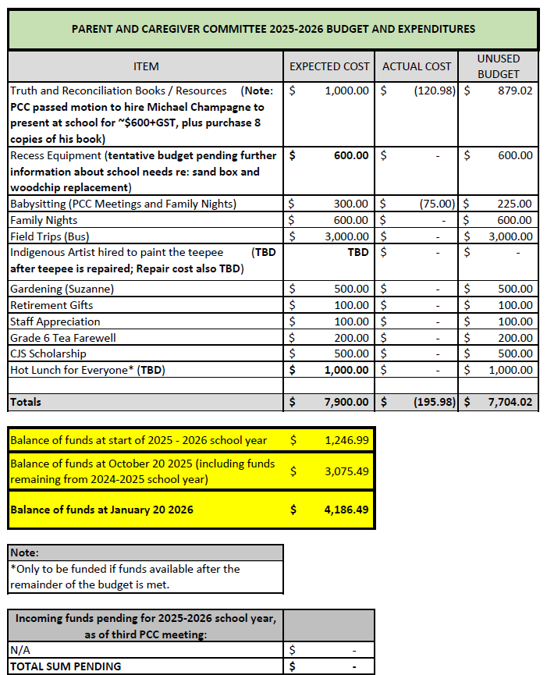

Notes from financial report:
- Recess equipment has been almost finalized – Erin will send the information
- Neha noted that our remaining fundraisers will be needed in order to meet our budget. Based on our current projections we are short approximately $1000, which the perogie and plant fundraisers should assist with.
Administration Report – Michelle

Admin Report for PCC – January 29th, 2026
Upcoming activities/Important Dates:
- February 2 – PD Day (No School for students)
- February 9 – Kindergarten Information Evening 6:00pm
- February 16 – Louis Riel Day (Schools Closed)
- February 17-20- Festival du voyageur
- March 9 – Author Visit
- March 13 – report cards posted
- March 26 – Student-Led Conferences

Festival du voyageur
Collaboration with k-6 Windsor School students on Friday the 20th.
Proposed activities include the following: spirit week, la tire, campfire, hot chocolate, outdoor activities, crafts, dancing (jig), pancake breakfast, Festival Bingo, stop drop and jig, books, etc.

PCC initiative updates
- Recess equipment order finalized
- Michael Redhead Champagne booked for March 9th
- Camp: grade 5/6
  - 44 students confirmed
  - School based fundraisers being planned

Michelle noted that the first estimate for charter transport was significantly higher than expected, and asked if PCC would consider using part of the field day bus budget line to assist. PCC noted that the field trip line is fully used each year, but suggested the front row raffle for the spring concerts be allocated toward the camp fundraising. Parents of the grade 5/6 students going could be recruited to sell the tickets at those events. Michelle noted that she will be continuing to explore additional possibilities (including alternate charters).

School updates
- Shifting and streamlining processes in the kitchen
- New schedule feedback has been positive
- Reminder for feedback related to school goals

Staffing Updates
Dylana, Aida, Taylor, René, Nicolette, Stephen

One last discussion: Janessa brought up the possibility of PCC organizing a letter/email campaign to advocate for better school funding (in response to the LRSD communication that went out on January 4th titled “Supporting our Schools”). Janessa to look into a way to have a link for families to input their info and auto send an email to local politicians.

Adjournment (1 min) 7:48 pm, Next Meeting April 30th, 2026
École Varennes Parent and Caregiver Committee Meeting
October 23, 2025 6:30 pm Agenda

This land is the traditional territory of the Anishinaabeg, Ininewak, Dakota, and Dene peoples, and homeland of the Red River Métis Nation. We acknowledge the harms, of both the past and present, that were and are inflicted on Indigenous peoples in Canada by a colonial, exploitative worldview and we, as the Parent and Caregiver Committee, dedicate ourselves to move forward in collaboration with Indigenous communities in a spirit of reconciliation.

Call to order (1 min) 6:43 pm

Introductions (3 min.) -Neha
Explanation that reports as written. Open to discussion/questions (pass at end of all reports)

President’s Report (3 min) -Neha
Brief overview of the meeting/purpose of this meeting & introduction to the current executive & administration.

Overview of positions
-Stands full

Current Positions of PCC
Chair: Neha Trivedi
Vice-Chair: Meghan Dobbs
Co-Secretary: Renée Friesen and Janessa Nayler-Giesbrecht
Treasurer: Erin EisBrenner

Open from last PCC meeting
Fundraising
- Fundraising options reviewed, included: 50/50, cash calendar, Bothwell cheese, krispy kreme donuts, Glen Lea plants, grocery store gift cards (straight purchase, or raffle), perogies (Perfect Perogies, Country Perogies), Pointsetta fundraiser (Shelmerdine, Lacost), Value Village, Kernals popcorn. Co-Op may offer best return for grocery card fundraisers.

- Glen Lea- possible fundraiser in spring. Table until future PAC meeting.

- Perogies fundraiser- could be done in winter months (Jan/Feb) as perogies can remain outdoors in designated area until pick up (less reliance on freezer space within school). Meghan will explore options for perogy fundraiser.

- Pointsetta fundraiser- Renee will explore details with Lacoste. Goal to have delivery early December.

- Motion passed to pursue Kernals fundraiser for November. Small price point makes this fundraiser more accessible for all families. Neha will contact Kernals for details. Goal is to have deliveries to school Nov 13-14th. Jennessa will create Canva poster for fundraiser (for school newsletter). Goal to set a 2 week window for orders.

Hot lunch for everyone (event, not fundraiser)
- Tabled for future PAC meeting. Students are receiving hot lunches at no cost on Tuesdays and Thursdays. If PAC funds allow at end of year, PAC can consider funding whole-school hot lunch or treat.

Varenne’s Garden Club
- Suzanne (School librarian/teacher) leads school garden club. She has provided a list of items required for garden. Budget will remain at $500 from PAC. Plan is to purchase items in the spring. Future discussions to occur re: families assisting with garden care over summer months.

New Business:
- Request to add PAC minutes to school newsletters. PAC chair will send minutes to Principal Michelle Kennedy to attach to next newsletter.
- Request to explore options to connect Kindergarten parent/caregivers early in the school year to support connection. Michelle Kennedy will bring to school team for discussion.
- Request for more information on use of Portfolio Nights vs. Parent/Caregiver-Teacher conferences. Michelle Kennedy reports division is exploring this. Open to options/changes.
- Motion to re-send Power School Update in next newsletter (Erin Eisbrennar, 2nd Meghan Dobbs).
- Motion (Erin Eisbrennar, 2nd Renee Friesen) to approve hiring of Michael Champagne for school event, and purchase of 8 of his books. School to raffle one book per grade. See School report.

Minutes from Sep 25 2025

Review minutes – attached (page 5-7)

Treasurer’s Report Financial Statements (3 – 5 min)
Attached
- Discussed order of expense list. Purchases typically made earlier in school year at the top of the list. Late year expenses at the bottom.
- Budget following deposit of parent donations will be $3350.
- PAC will vote in meetings re: covering cost of food for family nights.
- Erin Sheldon, VP, explained history/tradition of feeder schools offering scholarship to high school students.
- Motion to accept payment for two childcare students for today’s PAC meeting. $25 each student.
- Michelle Kennedy awaiting responses from P.E staff re: recess equipment needs, and from maintenance staff re: sand and woodchip needs for school yard.

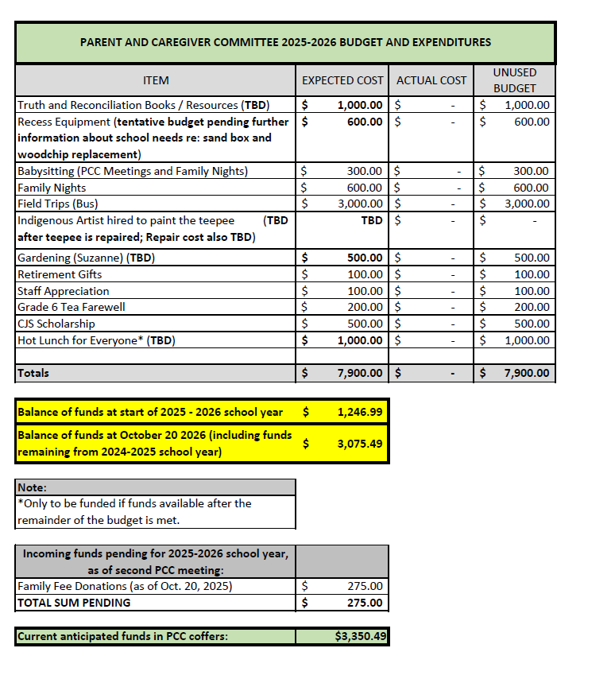
Administration Report – Michelle

Upcoming activities:
- Spirit Week October 27-31
  - Monday: Pajama Day
  - Tuesday: Sports Day
  - Wednesday: Varennes Wear or Dress in Blue
  - Thursday: Orange & Black
  - Friday: Dress as your favourite character
- November 7th: Remembrance Day assembly 10:30
- Conferences – Student-Led model (Varennes book swap): November 27th 4:00-7:30

Staffing constraints:
- Current postings for Lunch Supervisors and crossing guard.
Schedule Change updates: Data showing community feedback
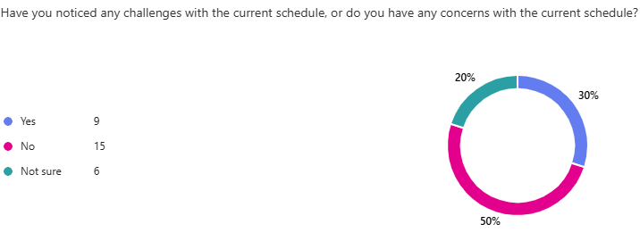
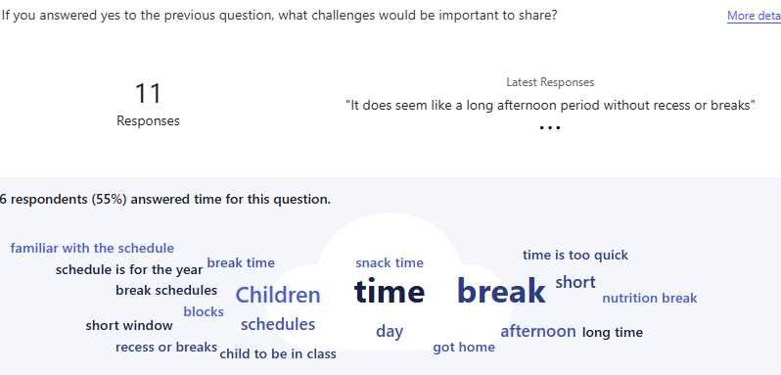
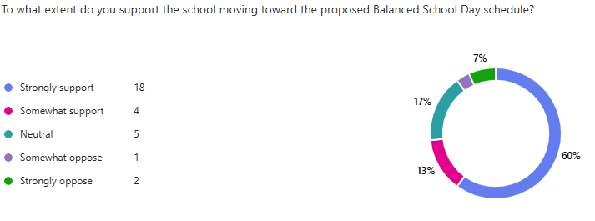

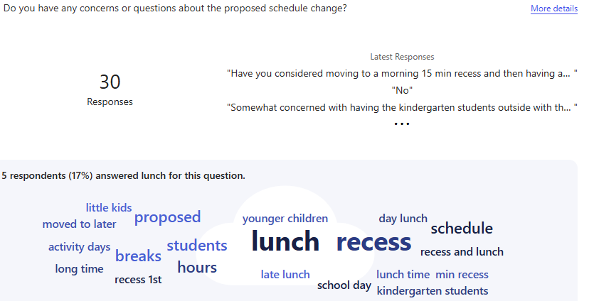
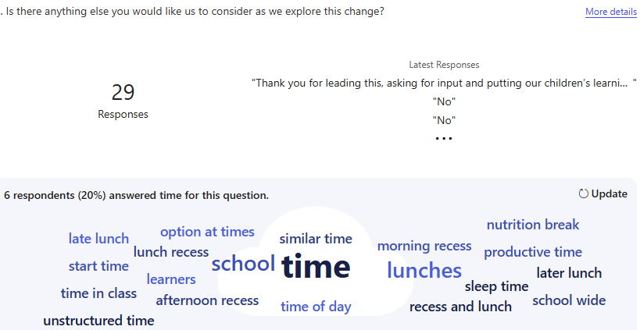

Following consultation with the community, the staff as well as divisional personnel, we will be moving to a more balanced schedule with an anticipated start in January. The final schedule will be shared at a later date.

Updates from the library:
- Potential author visit: https://www.michaelredheadchampagne.com/
  - Michael Redhead Champagne is working towards a revolution that dismantles harmful systems and builds up new ones based on justice, equity and love. A community leader from Winnipeg's North End with family roots in Shamattawa First Nation, Michael is host, helper, published author, on-screen personality and sought after public speaker. Michael happily shares his words, wisdom and welcoming energy across Canada and around the world.
  - Michael's first children’s book, We Need Everyone, premieres with HighWater Press in January 2024.
  - Michael’s standard school rate is $600n + gst

School based goals
- Prioritizing oral French
- Continuing to establish community connections
- Ongoing collaboration amongst grade level teams
Supporting grade level teams with the support of members of the SCST

Important Dates:

Adjournment (1 min) 7:58 pm

Next Meeting January 29th, 2025

