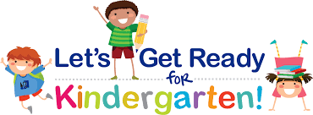f
Ready for School Program
Children born in 2o21 and registered to enter Kindergarten at
Glenwood School in September 2026 are eligible to attend.
Program runs twice per week from April 15th to June 3rd, 2026.
Monday and Wednesday (or as noted on schedule) mornings-9:00-11:15

Registration begins February 12th and closes March 20th
This is a FREE program, space is limited.

The Ready for School program is an opportunity for your child to:
Play, learn, interact, and grow comfortable in a school setting.
Learn and practice basic concepts, skills, and school routines.
Enjoy games, songs, stories and other fun activities.

To register or for more information, please contact:
Glenwood School Family Centre
204-233-3619 x-3274
Kelly.beckinghamjohnson@lrsd.net

