Dear Parents,
United Way believes that when you help to build up one person, you are helping to build up whole communities. They envision a future where all of our communities are healthy, vibrant places to work, live and raise families. When you donate to the United Way, you are helping to achieve that vision by giving people opportunities to move from a life of poverty to one of possibility, strengthening communities where people can live healthy lives, and giving children and youth the chance to achieve their full potential.
Together, we can create opportunities for a better life for everyone in our communities. We invite you to be a part of making a difference by participating in our United Way Piggy Bank Spirit Week from October 28 - November 1.
Coins being collected Theme of the day – choice of:
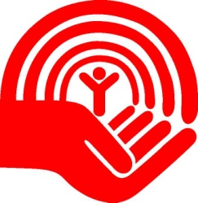
Monday 5 or 10 cents Silly hair or wacky socks
Tuesday 25 cents Sport or superhero
Wednesday loonies Hats or tie dye
Thursday toonies Costume or black & orange
Friday paper money or coins pyjamas or rainbow

Please note that everyone is encouraged to participate
whether they contribute monetarily or not.
We will also be collecting any gently used coats, hats, scarfs, mittens and boots for our Koats for Kids program. For some children in our city, having a warm coat means attending school on a cold day instead of staying home. There will be a large box set up in the foyer of the school (near the parking lot doors) to collect all donations.
Thank you for your support and your generosity.
Lise-Anne Mandaliti
On behalf of the MAG United Way Committee

