

Wyatt Community Weekly Wire

March 24 - 28, 2025

Issue 27

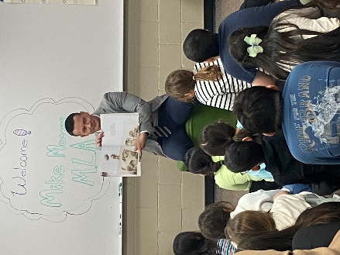**I Love to Read**

Thank you to MLA Mike Moyes, who read to Ms. Pooley and Mrs. Malhi’s classes today as a special guest reader as a part of our I Love to Read celebrations.

**Term 2 Report Cards are Posted**

Please find below two helpful links to access the portal and the reports.

[How to Create a Parent Portal Account](https://u45793925.ct.sendgrid.net/ls/click?upn=u001.lNPzGlJ82wKXzs3GtNc4z7-2FBpTZUsKLFWMfn9CCuX-2Fc2Nu3gUBN5SNCrnRBvJMPgO9CBo88TUYLUZQK0hGZnLkpYxSAhDKIoJ-2FtdkitpUIo-3DvTwL_AQymMr02VFNcM3ZbConlMoKYMtIkFo2em1ICkVReS0x6tDJ1VvGoENmAGq8JRyKm8LGKelXqid3oUFLA0AFE6OaYOxp5kcg2IiMUV6kf7fswObd-2FwbcKvrQJtmTzNCX-2FtkM1ltB3ZTSiNviEv66V1zyeXEB3X1-2BesW5386VSWYgzL-2BFzqmcsuahTeM6-2Bm6ghbfb0Vg9nYI-2FgiI3jXAKqz7hS0z0mUqc0HFfpkwgxr4crdRTv-2FKddGXZVOC0vczhiZF1rWMvWk4Gx-2FJqIGXxuSMOoMrd1bpP7JuLO37wFGhc4dvsfdMqk2NDj2wVqCWxQAUmraBHZ11mr-2FrsmyR3oMA-3D-3D)

[How to Access the Report Card](https://u45793925.ct.sendgrid.net/ls/click?upn=u001.lNPzGlJ82wKXzs3GtNc4z7-2FBpTZUsKLFWMfn9CCuX-2Fc64ZKOlqc7GXdg5tlohSyyRpK0PGrljDQXfhjveKcrwqlSTtANHsiKyn6DRzEJPBA-3Dh5QH_AQymMr02VFNcM3ZbConlMoKYMtIkFo2em1ICkVReS0x6tDJ1VvGoENmAGq8JRyKm8LGKelXqid3oUFLA0AFE6OaYOxp5kcg2IiMUV6kf7fswObd-2FwbcKvrQJtmTzNCX-2FtkM1ltB3ZTSiNviEv66V1zyeXEB3X1-2BesW5386VSWYgzL-2BFzqmcsuahTeM6-2Bm6ghDmyBp6bkB7-2FlCU-2BkOmiMpVqrBzFNzntVqI87u8gfywls2wu8VUTrfuGe1RsT9QXuOfenQZqPr4GblkdVhIf22Yg-2BZuPN1QsiFOWIHWqMPnpnYO0A5B8E3BzLqCpc38JHq-2BQGzdnop1q4p24-2FFR0ZLg-3D-3D)

**Student-Led Conferences**

A reminder that **Tuesday, March 25th,** (early dismissal day – 2:30 p.m.) is our **Student-Led Conference Open House from 3:30 – 6:30 p**.m.  Families do not need to prebook a time as it is a drop in format.

**Spring Break is Almost Here**

A reminder to families that the last day of classes is Friday, March 28th.

Spring Break is from March 29th – April 6th. Classes resume April 7th.

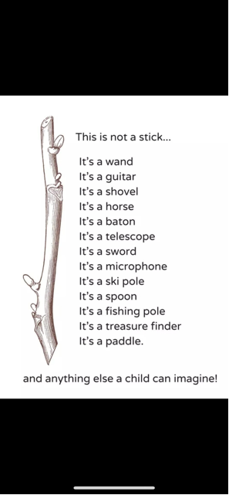

**Week at a Glance**

|  |  |
| --- | --- |
| **Monday, March 24th, 2025 Day 5** | Gr 7/8 badminton 11:45-12:45  Guest Reader – David A. Robertson Grade 3-6; 9:30-10:30 in the gym |
| **Tuesday, March 25th, 2025 Day 6** | Choir noon  Early Dismissal 2:30  Student Led Conferences 3:30-6:30 |
| **Wednesday, March 26th, 2025 Day 1** | Hockey 9:30-10:30 – King/Prieur 10:30-11:30 -Pooley/Malhi  Gr 5/6 choir to Meadowood Manor  Guest Reader Tyler Blashko – King/Prieur 10:45 in the library  Family Studies Practicum 11-11:45am Art Club Grade 6-8 - 3:30-5:00pm |
| **Thursday, March 27th, 2025**  **Day 2** | Choir noon  Gr 7/8 badminton 11:45-12:45  Golden Dragon Award Ceremony 9:45- 10:30 in the gym |
| **Friday, March 28th, 2025**  **Day 3** | Dance Club Gr 5-8, noon Drumming with Kookum 9:00-11:30  **Last Day of classes before Spring Break**  Meals2Go |
| **Upcoming Important Dates:** | * February 28 (sundown) – March 29 (estimate) Ramadan * April 10 – Pancake Breakfast * April 11 – PD Day, no school * April 18 – Good Friday – No School * April 22 – Class Photos |