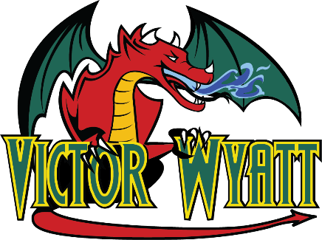

Wyatt Staff Weekly Wire

March 31st – April 4th, 2025

Issue 28 SPRING BREAK EDITION

# Spring Break 2025

# Wishing all of our Wyatt families and students a fantastic

# Spring Break filled with rest and fun.

# Let’s hope this new dump of snow melts quickly! 😊

# Classes resume on April 7th, 2025. We will look

# forward to welcoming students back then.

|  |  |
| --- | --- |
| **Monday, March 31st, 2025** |  |
| **Tuesday, April 1st, 2025** | SPRING BREAK |
| **Wednesday, April 2nd, 2025** | NO SCHOOL |
| **Thursday, April 3rd, 2025** | ENJOY YOUR TIME OFF! |
| **Friday, April 4th, 2025** |  |

# 

Wyatt Staff Weekly Wire

April 7-11, 2025

Issue 28