|  |
| --- |
| Wyatt Community Weekly Wire  April 14-18, 2025  Issue 30 |

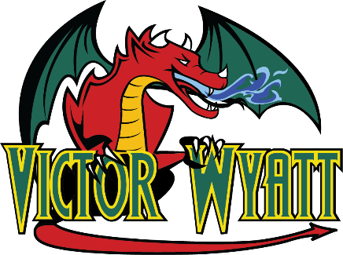

# Before & After School Childcare Survey – Action Required

As a part of Strategic Action 4.3 in our Multi-Year Strategic Plan, the division is working to increase the availability of before-and-after school childcare in our schools.

To help us move forward, we are asking all K-5 parents to participate in this important survey to help us move forward to create more before-and-after school care in LRSD. Your voice will help us to understand the current needs within our community.

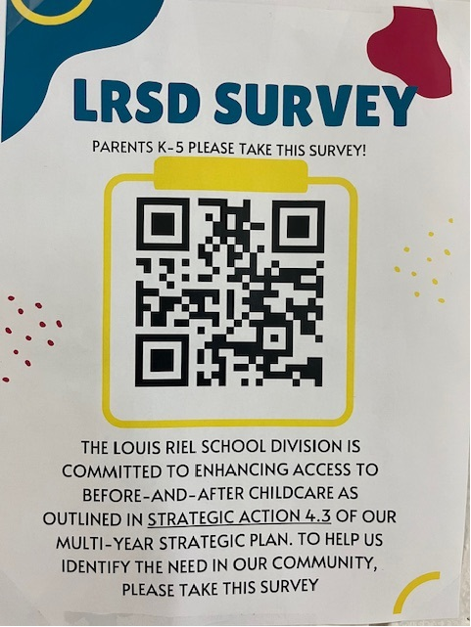

**Spring Programming at RDC**

# 

**Ceremony**

With Carolyn Moar &

Melvin Moar

The Full Moon Ceremony is a traditional

Indigenous Ceremony honouring our connection to Grandmother Moon.

**May 8th, 2025**

**June 12th, 2025**

**5:30pm**

**Week at a Glance**

|  |  |
| --- | --- |
| **Monday, April 14th, 2025**  **Day 3** | Gr 7/8 Badminton noon |
| **Tuesday, April 15th, 2025**   **Day 4** | Gr 7/8 Badminton noon |
| **Wednesday, April 16th, 2025**   **Day 5** | Gr 7 Divisional Badminton Tournament    Art Club Grade 6-8 - 3:30-5:00pm |
| **Thursday, April 17th, 2025**   **Day 6** | M.A.D.D. presemtat  Gr 8 Divisional Badminton Tournament  Meals2Go |
| **Friday, April 18th, 2025** | GOOD FRIDAY  No School |

**Upcoming important dates:**

* April 20 – Easter
* **April 22 – Earth Day**
* April 22 – Class Photos
* April 22 – Band Trip Band Level One Festival
* April 22 – Prieur/King to the Mint
* April 22 – Early Dismissal 2:30pm
* April 23 – Bus Evacuation
* April 24 – Pooley/Malhi to the Mint
* April 25 – Drumming with Kookum 9:00-11:30 am
* April 28 – Student Vote Grade 3-8 in the library pm
* April 30 – Honour Band Concert