Wyatt Community Weekly Wire
May 19 - May 23, 2025
Issue 35

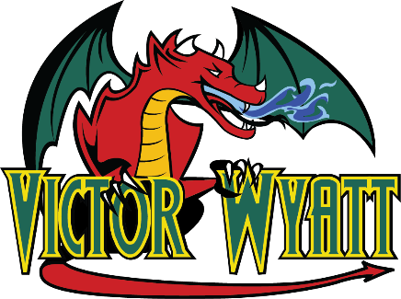



No School Monday, May 19th, 2025

A reminder that it is Victoria Day on Monday, May 19th and that there are no classes. We hope families enjoy the long weekend ahead.

Family Learning Night
This week’s Family Learning Night focused on bridge building in family teams while meeting specific building criteria. There were eight different prize categories that further challenged families as they considered their designs.


Thank you to all the families who actively participated in this event and made it so fun. An extra special thanks to Ms. Brooke for all her hard work and creativity in planning and organizing the night and to Ms. Dana and our custodial team for providing extra helping hands throughout the evening.

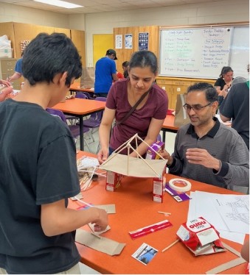
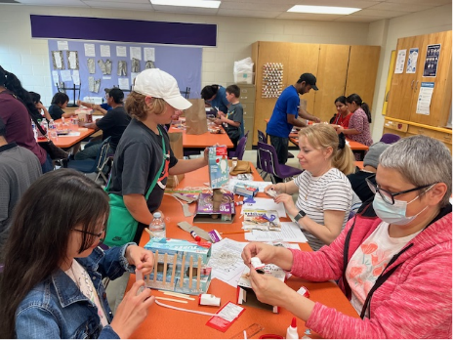

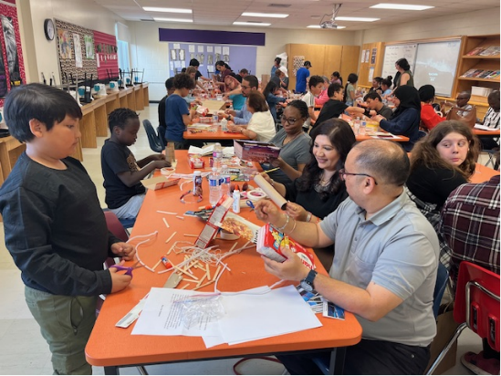
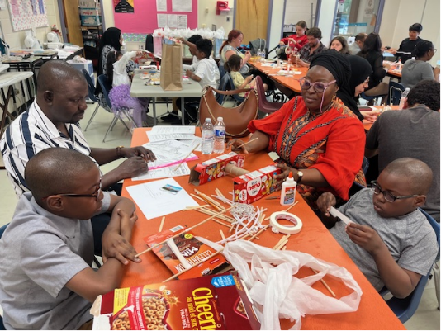

Powwow Graduation – Save the Date


Week at a Glance

Monday, May 19th, 2025 | Victoria Day No Classes
Tuesday, May 20th, 2025  Day 3 | Gr 7/8 Leadership at noon
Wednesday, May 21st, 2025  Day 4 | LRSD Track & Field Championship Meet  (must qualify)  PowWow Club 6:00-7:30 pm
Thursday, May 22nd, 2025
Day 5
Friday, May 23rd, 2025  Day 6 | Dance Club Grade 5-8 noon  3/4 Pooley AM Community Activity  Meals2G0

Upcoming important dates:
May 27 – Early Dismissal – 2:30 pm
May 28 PowWow Club 6:00-7:30 pm
May 29 – Immunization Clinic AM
June 4 – Powwow Graduation – Grand Entry 5:15 p.m.

