Main Floor 5:00 - 9:00 p.m. Come and Go
Career Centre | Gym | Gym | Gym | Cafeteria | Cafeteria | Hallways
RBC Interview Centre  Practice Interview skills  with RBC Professionals | Career Café  Sit down and converse with  60+ workplace professionals from diverse professions and industries, learn day-in-the-life goals, skill needs, education pathways, and everyday habits | Post-Secondary Institutions  Explore a variety of education pathways and questions with 30+ universities, colleges, and schools | Apprenticeship  Discover trades, technical programs, and apprenticeship options at the Louis Riel Arts & Technology Centre and post-secondary programs outside LRSD | LIVE Job Boards  Seek a live job with support from  - YES MB  - Work in MB (WIM)  Giving back  Discover volunteer opportunities with Volunteer MB | Career Café  Meet Essential & Emergency Professionals,  New Media MB Pixel Pals,  WPG Game Collective  Arts Internships  Apply with Creative Manitoba – film, gaming, music, creative writing | Careers in the Drone Industry  Play in the Cage of Drones  Newcomer Supports  Show your love for Canada  Non-Profits  Discover unique career paths that make a difference
Main Floor Pastry Classroom 6:30 - 7:15 p.m. Scheduled Talk
Talk: “The Art of Entrepreneurship”: Noah Wilson, Biz Dev. Manager, Indigenous Youth, Futurpreneur; Scott Angus, Special Projects Manager, Johnston Group; Lucas Caracas-Fort, Lucas-Star; John Maneer, Naturely; Andres Bazin, Lineage Distribution
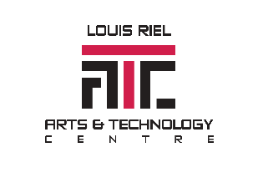

What’s the plan to connect your dots?
2024 Career & Post-Secondary Symposium

ONE NIGHT ONLY!

November 14, 5-9 p.m. Louis Riel Arts and Technology Centre

